Name :- Krish Menat Roll no :- 43 FyIT

Assignment 3

# Q1) Create the following given table with appropriate datatype and constraints.

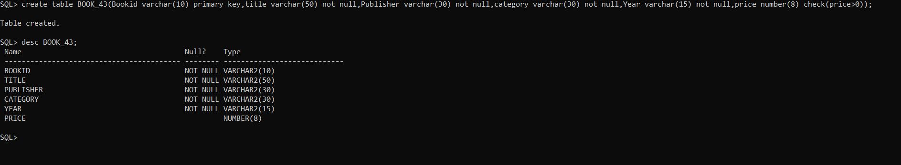

create table DISTRIBUTOR_43(Distid varchar(6) primary key,Distributor varchar(20) not null,City varchar(30) Default('Mumbai'),Discount varchar(30) default('15'),Creadit varchar(15) check(Creadit>0));

desc DISTRIBUTOR_43;

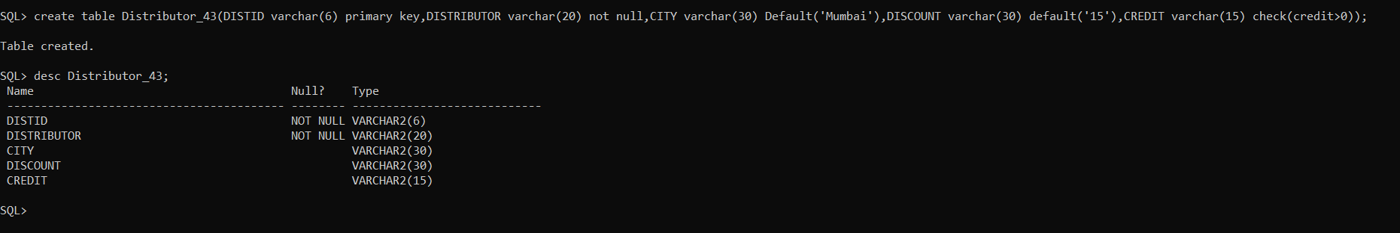

create table ORDERS_43(Orderno varchar(20) primary key,Title varchar(30) not null,Distid varchar(30) references DISTRIBUTOR_43(Distid),Qty varchar(15) check(Qty>0),Bookid varchar(10) references BOOK_43(Bookid));

desc ORDERS_43;

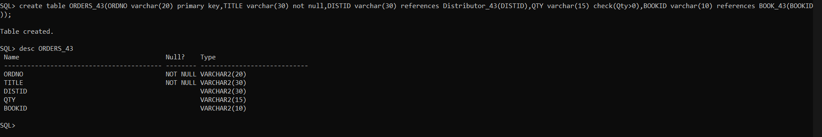

# Q2) Answer the following queries.

## 1. Rename the table Orders as Order_Details.

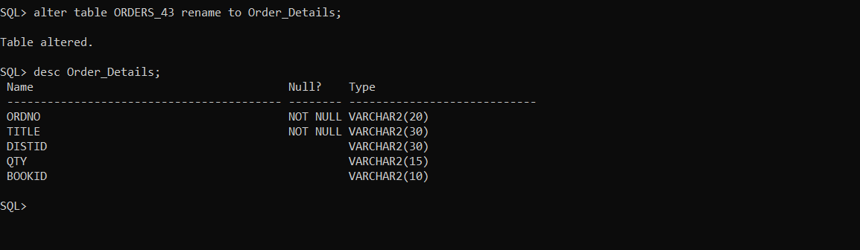

## Add a column Author in Book table with appropriate data type.

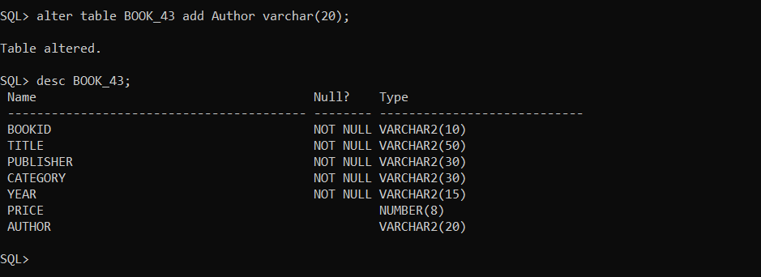

## Delete the column Creadit from Distributor table.

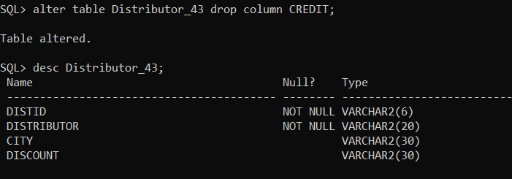

## Update the data type of column city to varchar(15) in Distributor table.

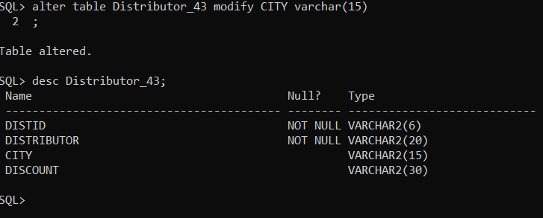

# 5. Add a column date in Orders table.

